Contents BA thesis

Mixtec languages
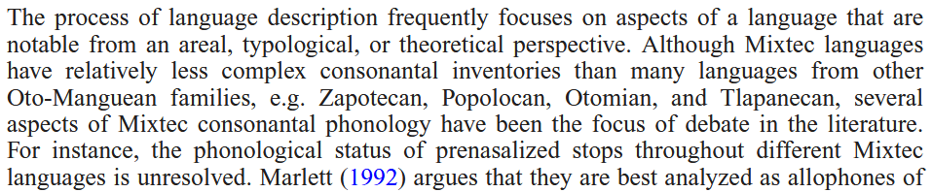
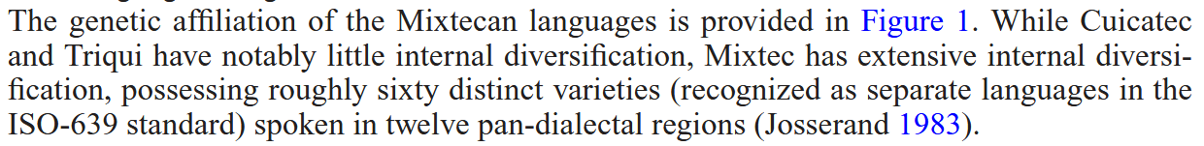

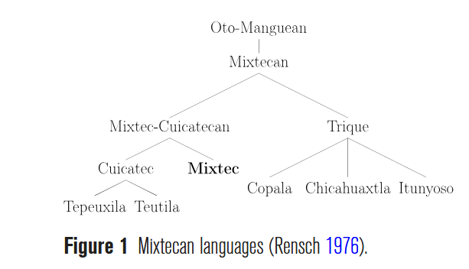
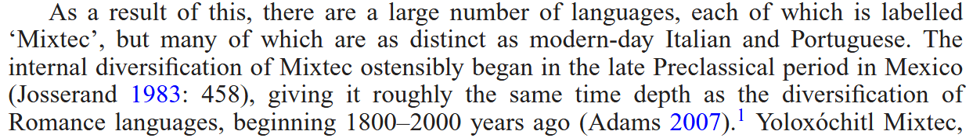

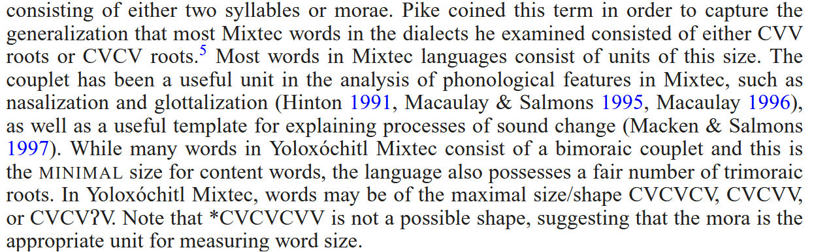

SMD Mixtec
Phonetic inventory
Syllable structure

Prenasalized consonants

Methods

